MOUNTAIN WILDERNESS INTERNATIONAL

Asian Desk

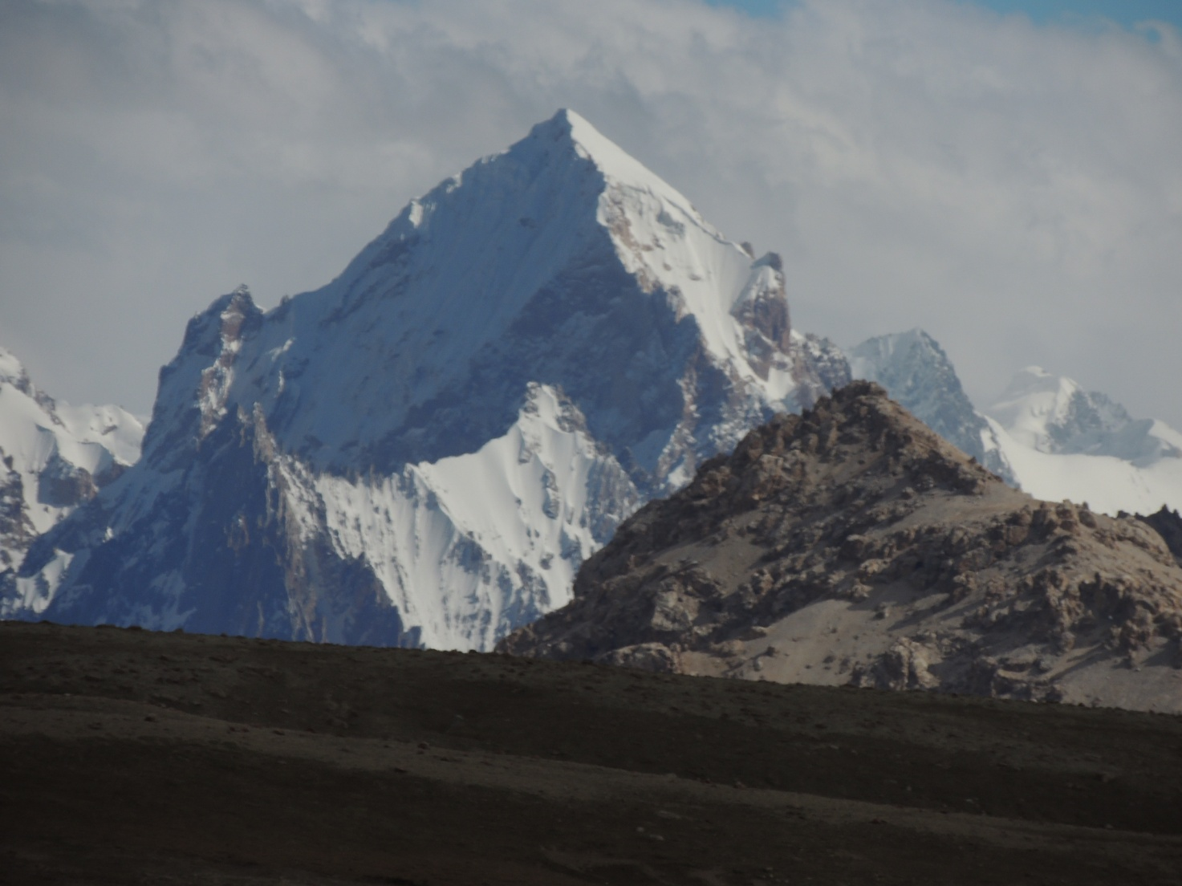

6000 meters peaks seen from the Shimshal pass ( 4700 m.)

THE WAKHI PROJECT

From September 3rd to September 29th a Delegation of Mountain Wilderness International (Asian Desk) visited Northern Pakistan with the aim of verifying on different levels the feasibility of a humanitarian project for the training and employment of young mountain people of upper Hunza (Pakistan) and Wakhan (Afghanistan).

The group consisted of the director of the Asian Desk, Mountain Wilderness International, Prof. Carlo Alberto Pinelli, the financial advisor of the Asian Desk Dr. Michele Branca, the lawyer Lorenzo Sotis and Mr AfzelSherazee, president of the Pakistani Chapter of Mountain Wilderness.

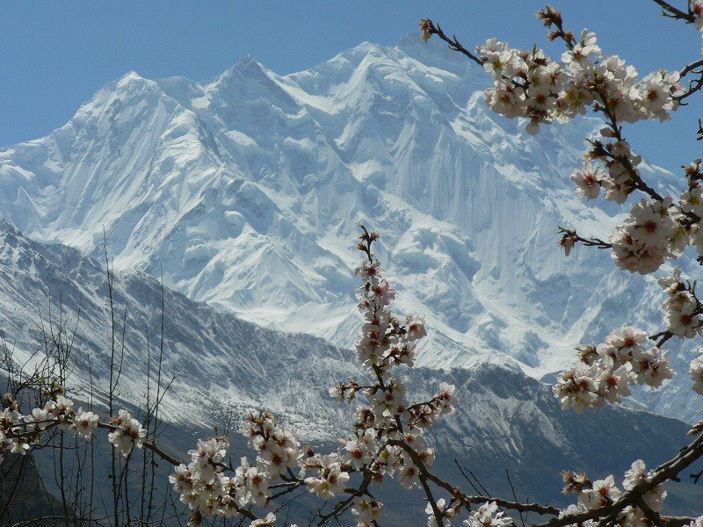

7000 m. peaks in the Hunza valley
We named the initiative “The Wakhi Project”. It is formed by several independent steps, all being parts of one global plan to be developed in the coming years, after being regularly checked for its feasibility. Here we are going to consider only the first step.

INTRODUCTION

The basic purpose of the project is to support the development of adventure and outdoor tourism in some western areas of the Great Himalayan mountain range (including Karakorum and Hindu Kush) that are scarcely visited by foreigners. A gentle and respectful kind of tourism which will improve the economical conditions of the communities living there, without damaging the environment or arming the local cultural heritage.

In the years 2005 and 2006, thanks to the cooperation of AKDN, UNEP, NEPA, the Italian and American Cooperations, Mountain Wilderness International organized in Afghanistan (Panjshir Valley and Afghan Corridor) two Courses of Environment-Friendly Mountaineering for local young people (male and female). The basic teachings of such courses were meant to produce professional or semi-professional staff to be employed as organizers of trekking tours, helpers for mountaineering expeditions, altitude porters, guides for outdoor activities, experts in rescue operations, rangers for National Parks and Reserves.

A couple of years ago a group of former Wakhi trainees from the Afghan Corridor approached the Asian Desk of Mountain Wilderness asking to hold a further course similar to the previous ones as the lack of well trained staff was felt more and more.

In fact, while the general situation in Afghanistan does not appear to be very satisfactory, the Wakhan Corridor is free of dangers due to political instability or extreme fundamentalism, and it can be and is reached fairly easily via Tajikistan.

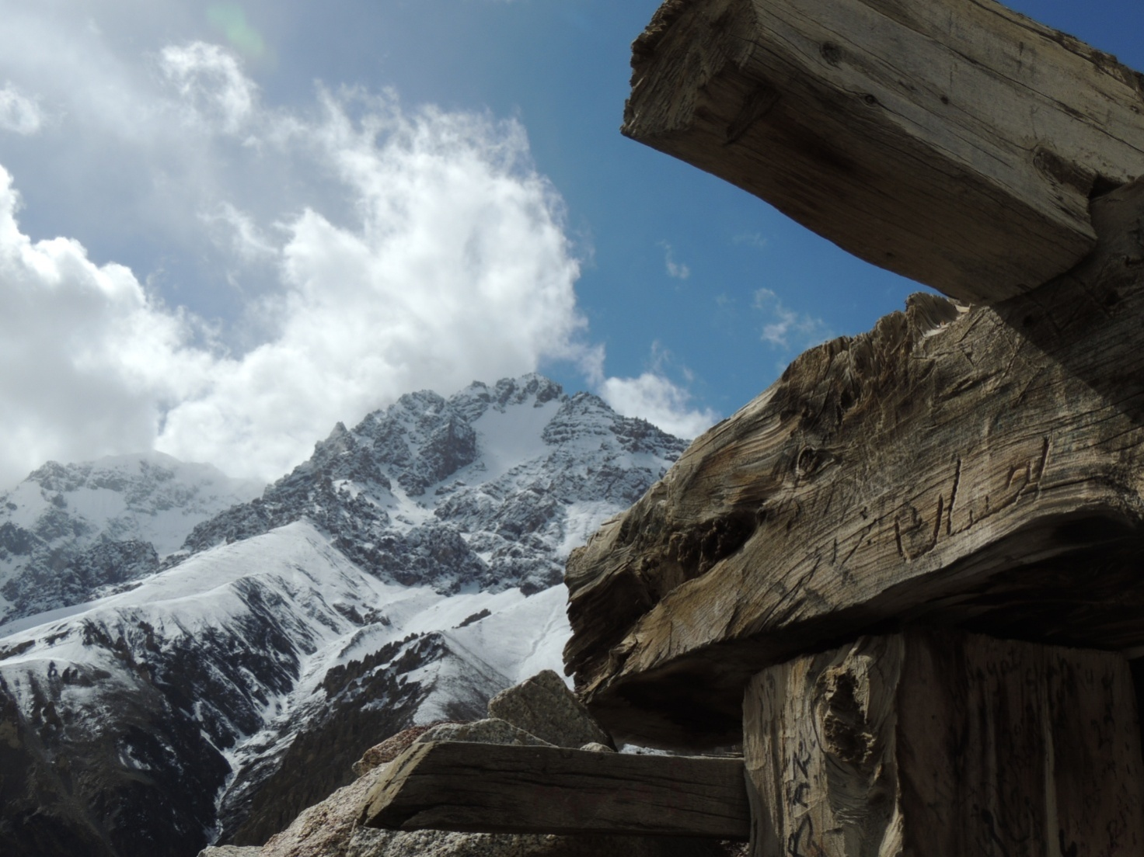

Landscape of the upper Shimshal valley

THE PROJECT

For historical and environmental reasons (which we believe our readers are well aware of), the Shimshal Valley (upper Hunza- Gojal) enjoys a well established and long tradition of mountaineering. A number of local men have been and still are hired by foreign mountaineering expeditions as high altitude porters; some of them have summited peaks of 8000 m, including K2. However, the hope of developing a regular income thanks to these skills is nowadays jeopardized by the Nepalese Sherpas introduced surreptitiously by the foreign commercial agencies into Pakistan disguised as mountaineering clients.
Apart from Shimshal there are excellent mountaineers also in other Hunza valleys, but not so many, and lacking an organization to support them. All these people would enjoy a significant improvement of their living standard if the massive flux of adventure tourists were, at least partially, directed towards the mountain ranges of the Western Karakorum and Hindu Kush, instead of concentrating them on the Baltoro area.

We are aware that for a steady development of a responsible tourism in the Wakhan area (Northern Afghanistan) more qualified and numerous staff is required (together with an intelligent plan of international communication and a plan for the efficient logistic assistance). At present Mountain Wilderness could take care of only one basic training course by providing a team – free of cost like in the past – of European instructors. However, this is most likely to remain an isolated initiative loosing quickly its efficiency in the years to come. To overcome this problem Mountain Wilderness suggests to organize in the upper Hunza a very specialized Mountaineering Course meant to train future totally reliable instructors (experts of rock and ice climbing , trekking guides, sirdars for mountaineering expeditions, instructors for student groups, team leaders for rescue operations, rangers, supervisors of the ecological wellbeing of the territory, etc.). A Course to teach how to teach. Candidates for such a course should be chosen only among the young people of the valleys speaking Wakhi and having already a real mountaineering experience. Pretty soon this first group of well trained instructors could be asked by the Aga Khan Organization to go regularly to the Wakhan area, in order to help train local candidates. This would be the way to make sure that the initiative has a long-term sustainable future.

Another important point in favour of this suggestion is that both the trainers and the trainees speak the same language, belong to the same faith and have the same cultural background. Obviously, this new group of instructors may display the acquired know-how also within Pakistan, organizing courses of various level for youngsters living in other valleys or mountaineering fans coming from the flatland and from big cities, or leading trekking groups in their valleys and glaciers. In the presence of such a group of well trained mountaineers it will be easier to obtain by the Pakistani authorities concerned efficient measures to stop Nepalese Sherpas (who, by the way, are paid a much higher salary by the foreign agencies than the one asked for by the Pakistani high altitude porters) to worm their way into the country. Moreover once the service offered will be of similar or equal quality, there would be no reason for the foreign organizations to pay a higher price for the qualified but illegal staff from Nepal.

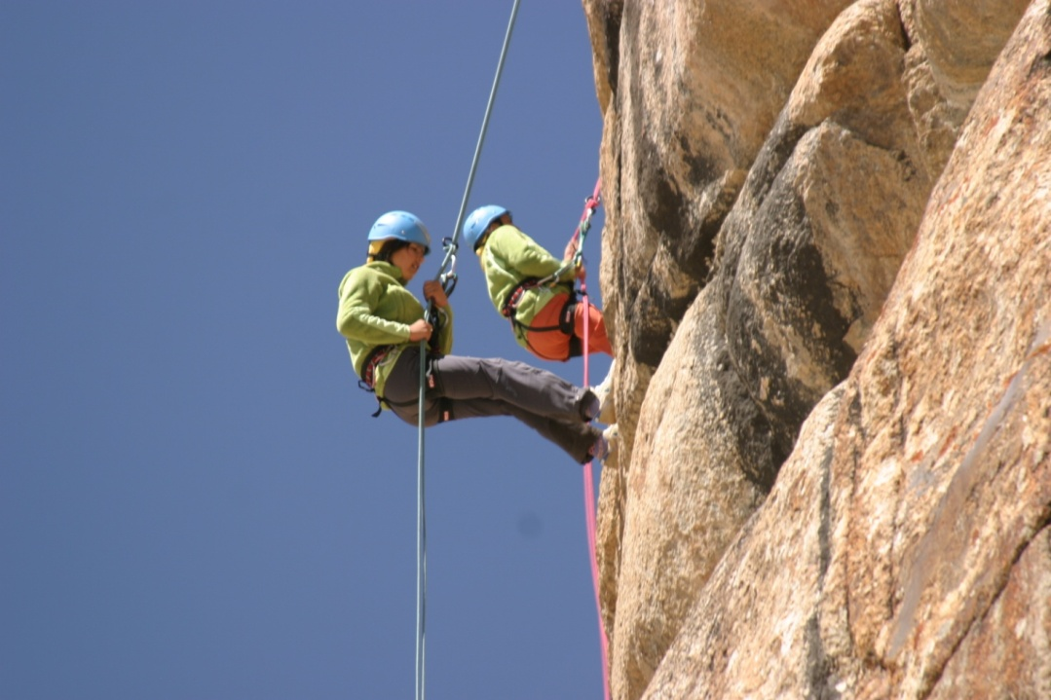

The Course for future instructors should be restricted to 20 trainees having Wakhi as mother language and some real knowledge of mountaineering. They should also own at least part of the necessary equipment required at high altitude. We would be in favour of accepting some two girls among the trainees (in Shimshal there is already a small but strong-minded group of girls practicing mountaineering).
Mountain Wilderness will send from Europe six highly qualified instructors who will operate free of charge. One of them will be a medical doctor specializing in troubles due to high altitude and rescue operations in the mountains. The theoretical subjects taught will include geography and geology of the great Asian mountain ranges, history of mountaineering in the Himalayas, the dynamics of glaciers and the risks of avalanches, the techniques of fixing and safely retrieving fixed ropes, the management of organic and inorganic garbage, the hygenic and logistic management of mobile camps, map and compass reading, etc.
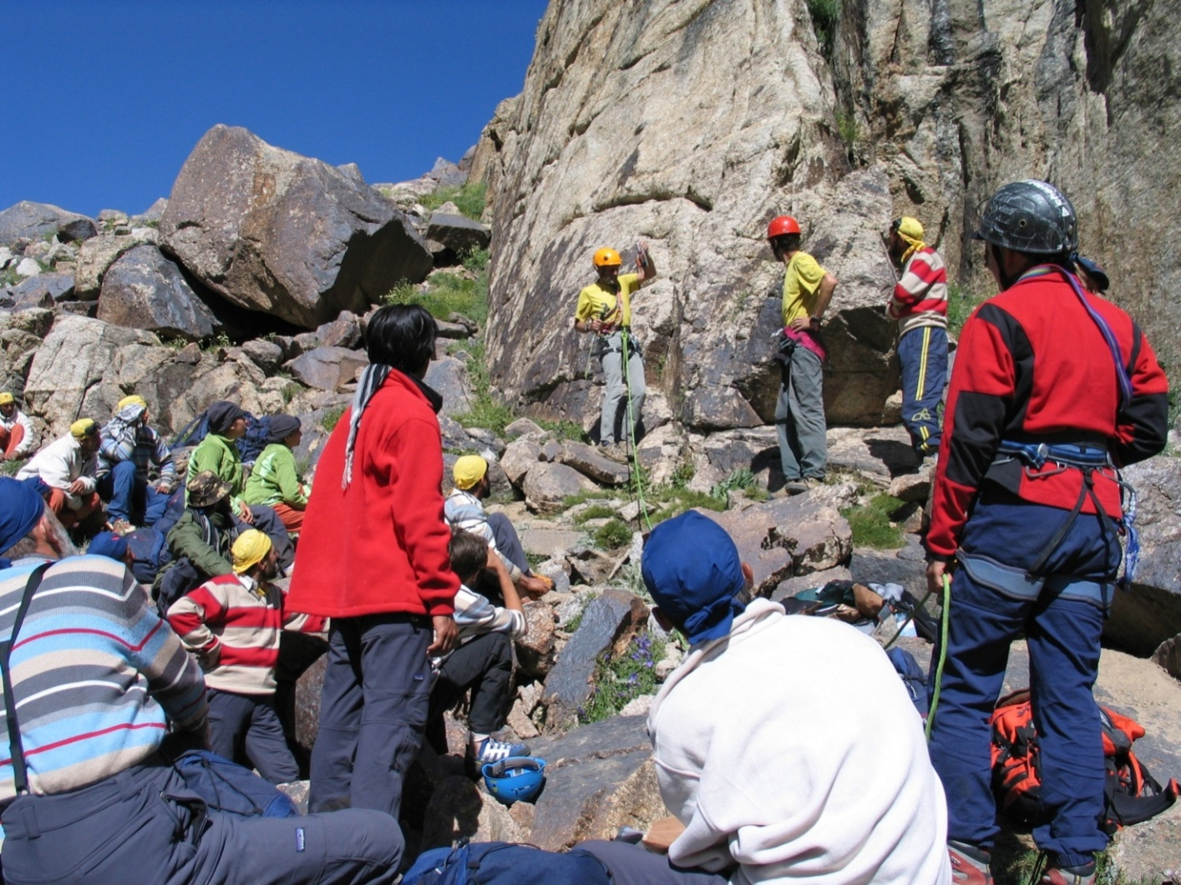
Mountain Wilderness is planning to organize this Course during the late summer 2013. The Aga Khan Foundation already granted to cover two third of the budget, provided that at least three trainees will come from the Wakhan Corridor.
The assignment of Mountain Wilderness will be to find what is still missing.

We may state that all Pakistani organizations concerned have expressed a clearly favourable opinion on the project.

On a Government level, the Federal Secretary of the Ministry for Education and Training , Mr QamarZaman, has promised his full support for the initiative. He stated that the Ministry he represents is in urgent need of initiatives of this kind.

The President of the Pakistani Alpine Club, Col. Manzoor, an old friend of ours, said he is available to give us a helping hand and stressed the importance of the project for a more efficient protection of the mountain environment.

Also the famous Pakistani mountaineer NazirSabir showed much interest and urged our group to realize the project as soon as possible. As a matter of fact, in his view the Hunza mountaineers are physically very strong, but they need a more accomplished technical training to be able to face the Sherpa competition.

The Mountaineering School of Shimshal has shown us deep respect and listened carefully to our description of the project. They fully agree with the purpose of the initiative. Obviously, most of the candidates chosen for the course will be coming from the Shimshall Valley. The entire community of the valley agrees with the opinion of the School Directors.

MOUNTAIN WILDERNESS INTERNATIONAL
Wakhi Project

A 15/20 DAYS COURSE FOR 20 TRAINEES

TWO SITES.: Pasu Glacier and village(10 days); base camp at Pasu Peak (6/8 days)

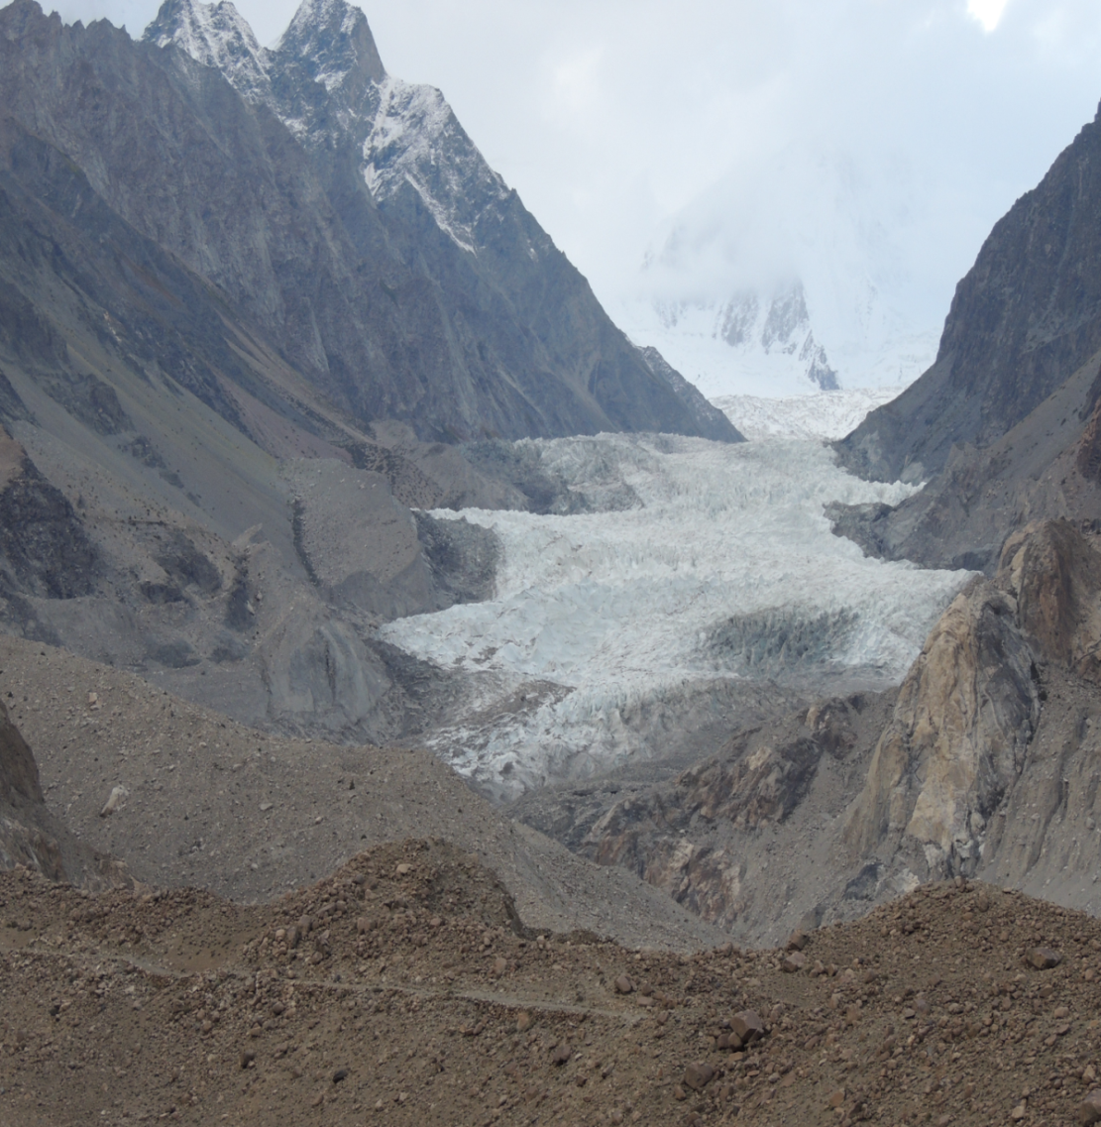

Pasu Glacier

DRAFT BUDGET

Gross currency exchange: 1 Euro = 120 Pakistani Rupies

Flight tickets for 8 persons (6 instructors and 2 members of Asian Desk)
€ 7.500

Excess luggage (200 kg) “ 1.000

Collective mountaineering equipment (dynamic and static ropes,
bolts and ice screws, stretcher, etc. (not including material and
equipment for trainees, if needed) “ 2.000

Kit for simultaneous translation “ 2.000

Office and preliminary expenses “ 1.500

Copies of lessons, teaching material on paper, certificates “ 1.500

Cook and camp assistant (for 6 days) “ 150

Porters from Pasu to base camp and return “ 1.000
Overland transport from Islamabad to Spillway and return “ 1.250

Boat for crossing lake and return “ 120

Local transportation (Pasu etc.) (to be charged to AKRSP)

Hotels on the way and food for 8 instructors € 4.150

Food during Course (instructors and trainees) “ 2.500

Renting of camping area at Pasu (for trainees) “ 40

Hotel accommodation for instructors at Pasu (9days) “ 100

Food for base camp € 1.670

Expenses for a courtesy interpreter (all inclusive) “ 420

Minimum per diem for trainees “ 1.250

Purchase of 10 tents “ 1.000

Purchase of 2 mess tents, 1 toilet, 1 kitchen “ 310

Tarpaulin ” 35

Rent for meeting hall in Pasu “ 35

Blue cylinder-containers “ 85

Various and unpredictable expenses “ 5.000

€ 34.615
=========

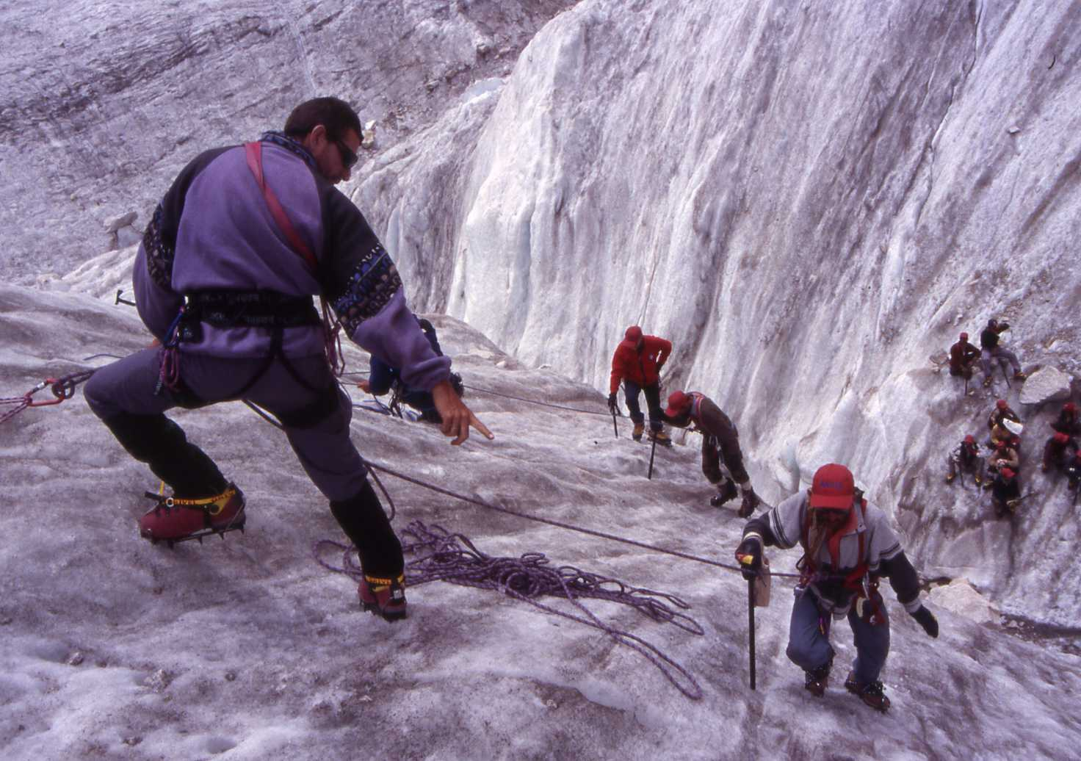
A Mountain Wilderness Mountaineering course in Pakistan

MOUNTAIN WILDERNESS: AN OUTLINE

The international movement “MOUNTAIN WILDERNESS – mountaineers of the world in defence of the Mountains,” was founded in Biella (Italy) in 1987 under the auspices of the Italian Academic Alpine Club and the Sella Foundation. To-day, Mountain Wilderness has national organizations in Italy, France, Switzerland, Castilla, Catalogna, Germany, Slovenia, Belgium, Holland, Pakistan, as well as numerous members in UK, East Europe and the United States. The International Board and the President are sided by 23 Guarantors elected every two years by the International Assembly, from well-known figures in the mountaineering world who have shown a real interest in protecting the quality of the mountain environment. Among them are: Prof. Edwin BERNBAUM (United States), Sir Christian BONINGTON (UK), Kurt DIEMBERGER (Austria, Honorary President), Patrick GABARROU (France), Alessandro GOGNA (Italy), Richard GOEDEKE (Germany), Bernard AMY ( France), Fausto DE STEFANI ( Italy), Patrik WAGNON ( France) etc.. At present the international president is Jordi QUERA from Catalunia, while Carlo Alberto PINELLI is the guarantor responsible of the Asian Desk.
Mountain Wilderness’s objective is to defend the large uncontaminated mountain areas, those domains of freedom and inner adventure that constitute an important heritage for all of humanity. In order to achieve this objective Mountain Wilderness prefers concrete, trenchant, at times provocative, but always exemplary actions capable of presenting each problem of conservation in its specific cultural framework. In fact, at stake to-day are not just the mountains themselves, but man’s creative relationship with nature as a whole.

During the last 20 years the movement has gained a reputation throughout the mountaineering and environmental world for serious and brave actions. So far Mountain Wilderness’s initiatives were carried out mainly in the European mountain areas, in first place in the Alps. Such actions were aimed primarily at opposing the building of an ever growing number of huts, via ferrata, access roads and cableways, and also to teach visitors to move and behave in an ecologically correct manner.

The Association is also working with South-American mountaineers, in the endeavour of finding a way for a sustainable evolution of tourism in the Andes that will bear in mind the environmental and cultural characteristics of the area.

Mountain Wilderness attaches great importance to its campaign started in 1989 in favour of the natural and symbolic integrity of Mount Olympus in Greece, threatened by foolish projects of exploitation for tourism. This campaign included a meeting on an academic level on Sacred Mountains of the World, held in Trikkala (Greece) during spring 1995.

Coming to Asia, Mountain Wilderness organized the first ecological expedition to save the great mountains of the Karakorum-Himalaya range. In 1990 the “FREE K2” expedition completed the environmental rehabilitation of the second highest peak in the world, freeing the base camp and the mountain’s slopes, up to 7000 meters, of tons of garbage and fixed ropes abandoned by previous parties. .

At the request of the Ministry for Tourism, Culture & Sport of Pakistan, in September 1995 and ’96 Mountain Wilderness held two very successful courses of Environmental Mountaineering, in order to form groups of efficient and reliable Liaison Officers, both civilians and military. The same courses were organized during 1997-1998 in Himachal Pradesh and in 1999 in the Garhwal area, India, at the request of the Indian Mountaineering Foundation. In 2001 Mountain Wilderness went back to Pakistan where was organized a technical and ecological training course for young people of the Chitral Valley (Pakistani Hindu Kush) wishing to acquire the basic skills needed to offer their services to foreign expeditions as high altitude porters and trekking guides.

In summer 2003 Mountain Wilderness carried out the OXUS MISSION – Mountains for Peace – aiming at re-opening the Afghan Hindu Kush to adventure tourism, as a sign of re-established normality. The expedition succeeded in reaching the summit of the highest mountain in Afghanistan, Noshaq (7492 m).

The Afghan Government has then asked Mountain Wilderness to organize 2 courses (2005 and 2006) of Environment friendly Mountaineering for future liaison officers, trekking guides, altitude porters, outdoors adventures organizers. These courses were attended also by four brave afghan girls. At present the Asian Desk is planning to go back to Pakistan (Upper Hunza- Gojal) and Wakhan with the precious help and cooperation of the Aga Khan Foundation.

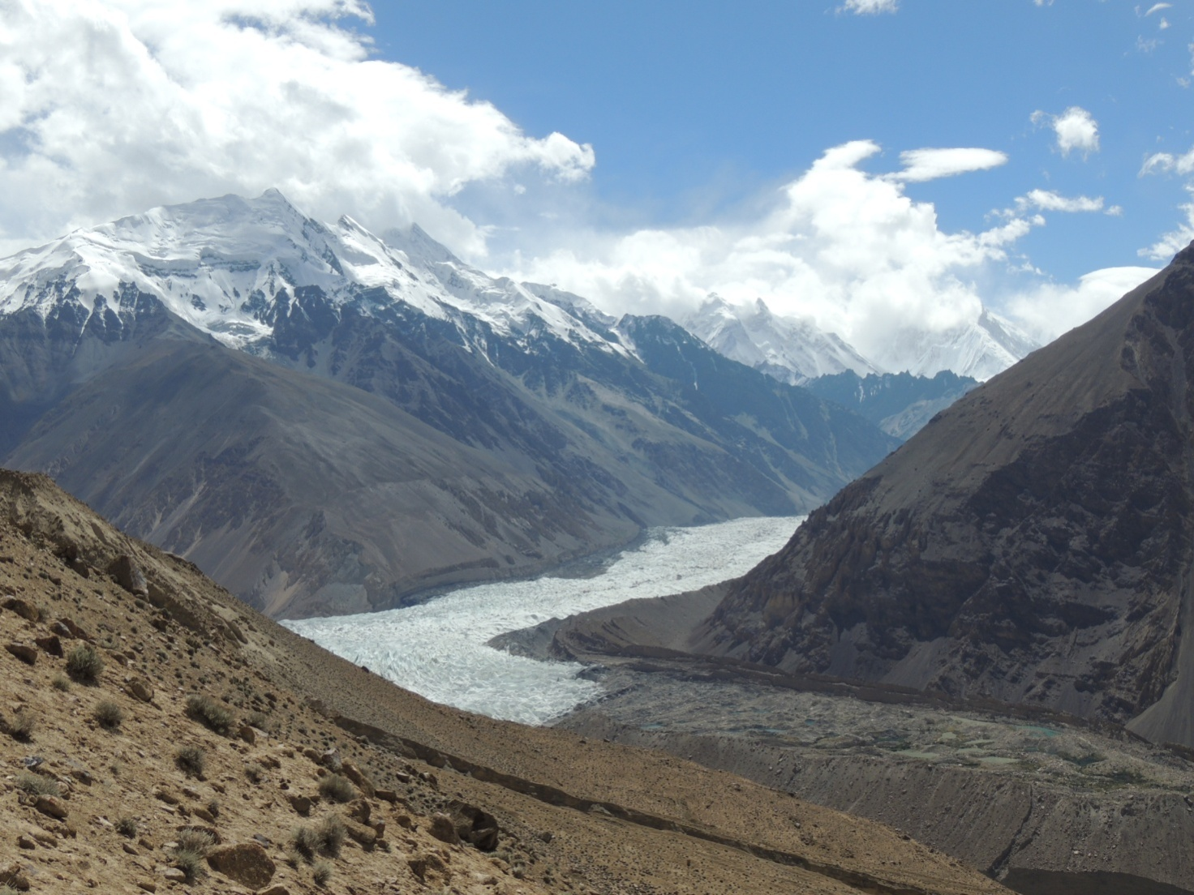

The Yazghil Glacier reaching the Shimshal valley

Contacts: mountwildintl@aol.com; pcarloalberto@aol.com

